

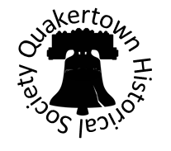

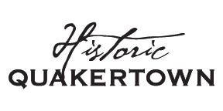

**August 2019**

**Events**

The QHS recently held another special program at the McCoole’s Arts Center for members and guests. On June 19th Gus Scheerbaum, a former long-time employee at Quakertown’s Trainers restaurant, came to speak about his years at the restaurant. He shared memorabilia and anecdotes of this historic Quakertown landmark. Look for more information about our next special program to be held in November.

On July 18th board members and volunteer’s gathered to help clean the Burgess Foulke House. There was dusting, vacuuming, windows to clean and more to be done. A big thank you to everyone, the house looks great! We will be having our annual meeting on September 12th at 7pm at McCoole’s Arts & Events Place; more details will be available shortly. We are also working on an Antique Appraisal Fair to take place in October as well as our popular Ghost Tours!

**Annual Meeting**

We will be having our annual meeting on September 12th at 7pm at McCoole’s Arts & Events Place. The terms of directors Vickie Blackmore, Danielle Bodnar & Shawna Serpe will expire at the Annual Meeting.

The Nominating Committee would like to report the following nominations to the general membership for election to board positions:

Three-year Terms – Vickie Blackmore, Danielle Bodnar & Shawna Serpe

**Update on Archives Activity**

We at the QHS are currently working on cataloging all the items we have in our collection. There are boxes and boxes of them! The ultimate goal is to digitize all of our archives for easy access. Future plans are to create themed-based, rotating displays at our museum at the Visitor Center across the street.

**Richard Moore Marker Dedication**

Mark your calendars! The dedication of the Richard Moore House Underground Railroad Station Historical Marker is set for September 14th at 1pm at 401 S. Main St. in Quakertown. There will be special guest speakers, reenactment groups, St. Isidore choir plus more to be announced later! To learn more about Richard Moore and his great work toward freeing slaves check out our website. www.QuakertownHistoricalSociety.org

**New Walking Tour Brochures**

The Quakertown Historical Society has new walking tour brochures available at the Visitor’s Center at the Upper Bucks Chamber of Commerce. Great way to learn about historic buildings in Quakertown and take a nice stroll!

**Burgess Foulke House Tours**

At this time, there are no set hours that the Burgess Foulke House is open. In the future, we hope to have enough volunteers so that we can make the building available on a regular basis to visitors. In the meantime, if you or someone you know would like to schedule a tour, please contact us (267-227-3864) and we will be glad to make special arrangements to accommodate you. Makes a great field trip for home schoolers!

26 N. Main St. P.O. Box 846

Quakertown, PA 18951

www.QuakertownHistoricalSociety.org

Phone: 267-227-3864

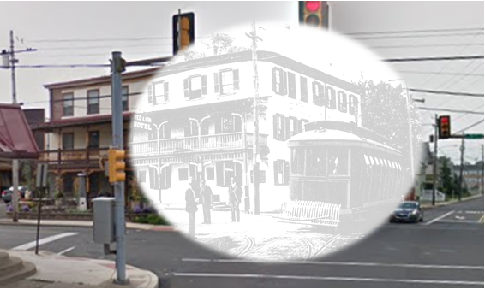

**Website/Social Media**

There have been some new articles and videos added to our website. A nice little clip from 1964 will take you back or show you what Quakertown looked like in that time. Plus we have our online store. There are cookbooks, coverlets, and other (gift shop type) items available for purchase with all proceeds benefiting the Historical Society. [www.quakertownhistoricalsociety.org](http://www.quakertownhistoricalsociety.org). Don’t forget to like us on Facebook!

**Membership**

At this time there are no membership dues for your QHS; we rely on the contributions from our supportive members and from the community at large. Please consider making a donation to your Quakertown Historical Society so that we may continue to serve you and the community with historical information.

**Volunteers**

If you would like to volunteer your time please call us or email us at info@QuakertownHistoricalSociety.org

We are grateful for all the volunteer help and support!

**Make a Donation**

Your Quakertown Historical Society is a 501(c)3 non-profit organization with an all-volunteer staff. Your donation will directly support your Quakertown Historical Society. Additionally, your donation may be tax deductible. You can also make a donation through our webpage (via PayPal) or check made out to: Quakertown Historical Society.

**Thank you!** We want to thank our volunteers who, throughout the year, help support the Quakertown Historical Society in various ways. We are forever grateful to you for your interest in, and celebration of the QHS.

What would you like to see more from your Quakertown historical society? Please submit suggestions to: QuakertownHistoricalSociety@gmail.com

**A Window Back In Time**

Have you ever wondered what McCoole’s at Main & Broad St’s looked like around the turn of the century? This window gives you a glimpse of then with today.