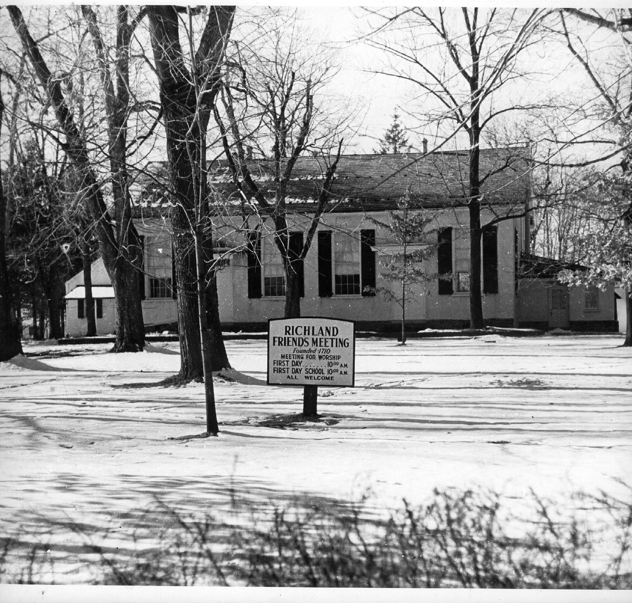





26 N. Main St. P.O. Box 846

Quakertown PA 18951

www.QuakertownHistoricalSociety.org

QuakertownHistoricalSociety@gmail.com

Phone: 267-227-3864

**September 2020 Newsletter**

**ANNUAL MEETING**

The Annual Meeting of the Quakertown Historical Society will be held on September 30, 2020 at 7:30 PM at McCoole’s Arts & Event Place, 10 S. Main Street, Quakertown, PA 18951. Year-end reports will be shared along with information shared on plans and goals going forward. An election will be held to fill expiring terms on the Board of Directors. It will be an in-person meeting, but you can also attend it live on Facebook.

SETEMBER 12, 2019 MEETING MINUTES

Minutes

Quakertown Historical Society

Annual Meeting

McCoole’s Arts & Events Place

10 S. Main Street

Quakertown PA 18951

September 12, 2019

The meeting was called to order by Acting President Jack Schick at 7:05 PM.

There were 15 members present.

The October 1, 2018 Annual Meeting Minutes were accepted on a motion by Vickie Blackmore

and seconded by Jim Lukens. (copy attached)

Treasurer Christina Landis presented the following Treasurer’s Report:

Opening Balance July 1, 2019 $ 9360.25

Closing Balance June 30, 2019 $ 7564.02

Receipts $11559.69

Expenses $13355.92

Indebtedness – QNB Loan – Balance A/O 6-30-19 was $1092.49

The Treasurer’s Report was accepted on a motion by Vickie Blackmore and seconded by Jim

Lukens.

Bob Roth presented the following Board Report:

The board met 10 times in fiscal year 2018/2019.

Election of Officers 10-1-18

President – John Wyatt

Vice-President – Jack Schick

Secretary – Bob Roth

Treasurer – Aimee Pattison

Election of Officer 7-2-19

Treasurer – Christina Landis

Board Resignations – John Wyatt (4-3-19), Aimee Pattison (7-2-19)

Board Additions 11-7-18

Jim Lukens (3 years), Lyn Treffinger (3 years), Vickie Blackmore (1 year),

Shawna Serpe (1 year)

Board Addition 4-3-19

Danielle Bodnar (1 year)

Board Committees

Events & Fundraising, Property Maintenance, Archives/Display, Membership, Finance, Public Relations & Strategic Planning

A Newsletter was re-established

Special Programs/Membership Meetings

Dr. Robert Leight – Richard Moore – March 28, 2019

Gus Sheerbaum – Trainer’s Restaurant – June 19, 2019

New roofs were installed on Burgess Foulke House and the Shed.

The Board Report was accepted on a motion by Vickie Blackmore and seconded by Steve

Biddle.

Plans/Goals

Jack Schick reminded the members that Saturday, September 14, 2019 is the Richard

Moore Marker Celebration.

Jim Lukens reported that two major fundraisers will be held in the fall. They are the

Ghost Tours and Luminary sales.

Jack Schick reported that all of the archive material is now located in the basement of

Burgess Foulke House. All the material will be evaluated in the coming year as to whether or not to dispose of certain items.

Lyn Treffinger reported that the Society properties are open for tours by appointment.

Vickie Blackmore reminded the members that volunteers are needed for a variety of

tasks. She also reported that the next Membership Meeting will feature a

presentation by Historical Recovery Services.

Christina reported that there will be a continuing effort to use the Website and Social

Media to promote the Society.

The Nominating Committee Report dated July 2, 2019 as previously distributed was presented.

(copy attached)

There were no nominations from the floor.

Nominations were closed on a motion by Vickie Blackmore and seconded by Christina

Landis.

Election of Board Members

By a unanimous vote the following individuals were elected to the Board for three-year

terms:

Vickie Blackmore, Danielle Bodnar & Shawna Serpe

The following individuals were appointed to the Audit Committee:

Torry Hinkle, Carol Roth & Logan Saugling

Member Comments

Sue Wilsey requested that the Board monitor Quakertown Borough Zoning Hearing Board Meetings. Specifically, when a building that has historical significance or is in a neighborhood that has historical significance is petitioning for variances that render the building “out of place.”

On a motion by Bob Roth and seconded by Vickie Blackmore the meeting was adjourned at 8:01 PM.

Respectfully submitted,

Bob Roth

Secretary

**2020 FUNDRAISER EVENT**

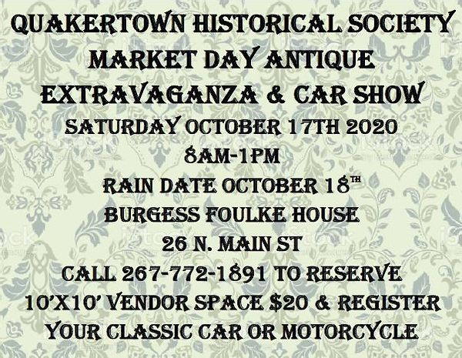

This will be the only fundraising event that the Society will be holding this year. There will be antique and vintage type vendors on site. There will also be a cruise type car show for cars 1975 and older. Tours will be conducted at the Burgess Foulke House, The Museum and Liberty Hall. If you are interested in helping as a volunteer, please contact us at 267-772-1891. Also, please do what you can to promote this event. We look forward to seeing you there.

**Quakertown – A Short History**

**By C. Norman Detweiler**

**Taken from Panorama Magazine February/March 1963**

Two hundred and sixty-two years ago William Penn issued a land grant to the first white settler in what is now Upper Bucks County. Griffith Jones, a Quaker from Wales, was given 6,000 acres in what was then known to the Indians as the Great Swamp, and later called by the early settlers, “Richland,” because of its fertile soil.

Nine years later, in 1710, land grants were made to Peter Lester, Morris Morris, Michael Atkinson, James McVaugh and John Moore, also Quakers, who came to America seeking freedom from persecution by the Church of England. Thus began a settlement that eventually developed into a village called Quaker Town.

While the first white settlers were predominantly English and Welsh Friends (Quakers), an influx of a different element. Germans, began to establish themselves in this area, about 1730. This brought in new dialects, new religious faiths, and new names, first of which were the John Bond and the John George Bachman families.

The Friends were the first to establish meetinghouse in this section of Penn’s Woods. A log house was built in 1721 at the confluence of two Indian trails, now known as Johnson’s Corner, where Station Road enters the old Bethlehem Pike. Prior to the building of the meetinghouse, the Quakers held services in the home of Peter Lester. With the increasing number of families locating several miles west of the original meetinghouse, a new structure of logs was erected in 1730 on the site of the present Richland Friends Meeting. Other newcomers to this area were the families of John Lester, Hugh Foulke, John Anderson, Arnal Heacock, John Phillips, William Morris, John Richards, William Jamison, Edmund Phillips, John Ball, John Michael Lightcap, Robert Gerard, William Allen, Benjamin Werley and Nicholas Austin.

With the increase in population an addition was built to the meetinghouse in 1795 and this served the worshippers until 1862 When the log house was torn down and a structure of stone erected. The Friends were pioneers also in the field of education and built the first schoolhouse in 1773. The log school was replaced with a red brick building in 1860 and this is still in use today as a First Day School. To preserve the weather-beaten bricks the building several years ago was given a coating of white cement.

Richland Library, third oldest in the United States, was founded by the Quakers in 1795, and is now located in one of the older houses on Main Street. Its shelves contain many rare and valuable volumes as well as manuscripts, also current best sellers, and leading magazines.

Situated as it was along the stagecoach road from Philadelphia to Bethlehem, the Quaker settlement grew in the vicinity of the meetinghouse, and in addition to private homes there followed the building of an inn a short distance away. According to Scull’s map of 1770, the public house of Walter McCool was erected about 1750 at the intersection of the stagecoach road and an Indian trail leading from the Lehigh Mountain eastward through this section to the lower end of Bucks County.

The Red Lion Inn, in continuous operation since its establishment before the Revolution, was originally a two-story stone building with traditional attic. Today it is a three-story hotel, it having been enlarged three times. Today the main dining room is in the original part of the historic old inn.

Not far from this hotel another tavern was later build, called the Green Tree Inn. Its original sign, bearing the painting of a lone pine tree, is now on exhibit in the Bucks County Historical Society Museum in Doylestown. This house today, in excellent state of preservation, is a private dwelling.

Diagonally across the street from the Red Lion an enterprising Quaker by the name of William Green established a country store in 1800. Until not too many years ago, this store, under various owners, was operated as a general store, but today it houses a jewelry store. Adjacent to the Green store was a two-story stone house behind which, legend has it, the Liberty Bell was hidden one night while being taken from Philadelphia to Allentown to escape capture by the British. The teamsters and Continental soldiers tethered their horses nearby and the men are said to have put up for the night at the Red Lion Inn. The house has since been called Liberty Hall and today is occupied by a barber shop.

Early historical happenings, it seems, centered around the village inn, and the Red Lion, a stagecoach stop in those day, was just such a place. In addition to the Liberty Bell episode it also is connected historically with the Fries Rebellion in 1798, so named after John Fries, a Milford Manor auctioneer, who led a group of settlers in refusing to pay a window tax levied by the Federal government to help finance the Revolution. Fries, after inciting rebellion in this and neighboring counties, was finally caught after a detachment of a thousand cavalrymen were send here from Philadelphia to take him into custody.

Fries was crying a public sale nearby when somebody warned him about the approaching troops. Jumping from the barrel on which he was standing, and followed by his pet dog “Whiskey,” he fled to the woods in the vicinity of what was then Bunker Hill, now Rich Hill. It was “Whiskey” that led to Fries’ capture, the dog letting out a yelp as a trooper rode by. Dragged from the bushes, Fries was placed under arrest and taken to Philadelphia where he was tried, convicted of treason, and sentenced to be hanged. The date was set, and the specified site was the crossroads at the Red Lion Inn. The gallows was erected, but the day before the execution Fried was pardoned by President John Adams and allowed to return to his family.

For years the growth of the Friends’ settlement in Richland area was barely perceptible, but with the influx of German and a few Irish immigrants, a hamlet gradually developed and by the turn of the century a neat little country village in Upper Bucks County was soon to receive a name.

It was in 1803 that the Federalist Government established a post office here and appointed storekeeper William Green the first postmaster. The village then became known officially as Quaker Town, the spelling of which remained two words until 1855 when the town became incorporated as a borough and the name was changed to its present form of spelling.

Centered as it was in what is now called the West End, Quakertown in 1932 was referred to in an atlas as “a small neat town of a single street, containing 40 dwellings, 2 stores. 3 taverns and a Quaker Meeting House.” Slowly the town grew, and by 1856 there were sixty-two dwellings, and increase of twenty-two in a quarter of a century. However, when the North Penn. Railroad was completed through this section, from Philadelphia to Bethlehem, there followed a spurt in the physical growth of Quakertown.

Though the town proper was a mile from the railroad, there sprung up to the east, where the right of way intersected the Milford to Newtown road, a new settlement of homes and business places that was to become known as Richland Center. This was the beginning of progress and prosperity, which led gradually to the growing together of the two rival communities.

Because of the development of the new settlement a mile from the town where the original post office was located, the residents of the new in 1867 petitioned the Postal Department in Washington for a post office near the railroad. The Department thereupon issued an order that the post office be removed from “uptown” to “downtown.” That riled residents of Quakertown proper and they in turn filed a protesting petition with Washington for its return to its original location. After five weeks Washington restored harmony here by returning the office to its former site and establishing another downtown under the name of Richland Center, located in Tobias Shive’s “Old Corner Store,” naming Ephraim Cope as its first postmaster.

In 1874 Richland Center was incorporated into the borough of Quakertown; however, its post office remained in operation (in its later location, the old car barn on East Broad Street) until 1914 when it was consolidated with the Quakertown post office which had been moved from Main Street to the Merchants Bank building at Second and West Broad Streets.

Industrially Quakertown has had a variety of pursuits. Early manufacturing included the making of pottery, bricks, boots, shoes, spokes, felloes, axe handles, creamery products, chewing tobacco, pipe organs, carriages, sleighs, clothing and cigars, which until shortly after World War I had been the leading industry in town. With the advent of machine-made cigars, the cigar factories one by one succumbed to automation and the experts in rolling hand-made “two-fors” had to look elsewhere for other kinds of employment.

With the demise of the cigar industry the factories were taken over bvy other manufacturing concerns and today thousands of employees in Quakertown produce men’s and women’s wearing apparel, hosiery, electric grills, soil pipe, leather welting, paper products, poultry equipment, wrought iron and metal work, glass and mirror products, furs, cabinets, overhead garage doors, building materials, bricks and tile, safety products (including asbestos suits for fire-fighting men in the Navy, Air Force and civilian fire companies), marine lighting, steel shelving, cigar boxes, machine shops, screw machine products, meat processing, ice manufacturing, marble memorials, rubber products, furniture and upholstering, cattle and poultry feeds, bread, cakes, pastries, cleaning and dying establishments, laundry etc.

Educationally Quakertown has always been a leader, and even today its school system ranks as a model in the State. The Friends started the first school soon after settling here, and in 1818 a “boarding school” was established by Richard Moore and Thomas Lester, which was quite successful for a short time but was discontinued “for private reasons.”

In 1858 the Revs. Abraham R. Horne, D.D., and H. Louis Bougher, D.D., established a “Normal and Classical School” which at one time had an enrollment of 400 students. It was located on Main Street and today the building is a three-family dwelling. In the early 1860’s Rev. Horne moved to Allentown and the school was converted into a “Soldiers’ Orphans’ School” This lasted only three years, closing in 1868, when the children were transferred to the Chester Spring School in Chester County.

Another educational venture was launched in 1866 when Levi Heacock and James Brunner opened a school “to prepare young people for teachers’ examinations. This too was of short existence.

Quakertown’s first public school was erected on what is now Fourteenth Street, a one-story stone building now tumbling into decay. The first Board members, elected on March 15, 1855, were Lewis B. Thompson, Samuel W. Miller, Elias Strunk, David Jamison, John Kaull and Lewis Jacoby. Their first meeting was on June 5 of that year when they voted to establish a 10-month term. The first teachers were a Miss Aaron and a Miss Meredith.

The next schoolhouse erected in town was on Roberts Street, now Tenth. The two-story structure, abandoned in 1920, is now owned by the Methodist Church and is used as an educational and community hall.

Subsequent buildings were the Central School on Sixth Street and the Franklin Street school, 1893. In 1911 a high school was erected next to the Central school, being occupied as such until 1929 when a new high school was erected on Seventh Street. The old high school was named the Lincoln grade school. With the continual growth of the town’s population, and the rising birth rate following two World Wars, the school district was required to erect still another building, the modern million-and-a-half dollar Quakertown Community Senior High School on Park Avenue between Sixth and Seventh Streets.